|  |  |
| --- | --- |
| C:\Users\HP\OneDrive\Desktop\WhatsApp Image 2022-11-17 at 12.25.02.jpeg | **PERSONAL EXPENSE TRACKER**  **APPLICATION** |
| **November 2022** | PROJECT REPORT SUBMITTED IN PARTIAL FULFILLMENT OF THE REQUIREMENTS FOR THE AWARD OF THE  DEGREE OF **BACHELOR OF ENGINEERING**  IN **ELECTRONICS AND COMMUNICATION ENGINEERING**  OF THE ANNA UNIVERSITY |
|  |  |
| |  | | --- | | **PROJECT**  **WORK** | | Submitted by  **PRAVEEN KUMAR M** **– 722819106064**  **ROOPAK S – 722819106079**  **ROSHINI DEVI B – 722819106081**  **VIHASINI R P – 7228191060110** |
| **BATCH**  **2019 – 2023** |  |
|  | Under the Guidance of  **Dr.S.Ramalingam,M.E.,Ph.D.,**  **Assistant Professor, ECE.** |
| **Electronics and Communication Engineering**  **Sri Eshwar College of Engineering**  (An Autonomous Institution – Affiliated to Anna University)  **COIMBATORE – 641 202** | |

**CONTENTS**

1. **INTRODUCTION**
   1. Project Overview
   2. Purpose
2. **LITERATURE SURVEY**
   1. Existing problem
   2. References
   3. Problem Statement Definition
3. **IDEATION & PROPOSED SOLUTION**
   1. Empathy Map Canvas
   2. Ideation & Brainstorming
   3. Proposed Solution
   4. Problem Solution fit
4. **REQUIREMENT ANALYSIS**
   1. Functional requirement
   2. Non-Functional requirements
5. **PROJECT DESIGN**
   1. Data Flow Diagrams
   2. Solution & Technical Architecture
   3. User Stories
6. **PROJECT PLANNING & SCHEDULING**
   1. Sprint Delivery Schedule
7. **CODING & SOLUTIONING**
   1. Feature 1
   2. Feature 2
8. **TESTING**
   1. Test Cases
   2. User Acceptance Testing
9. **RESULTS**
10. **ADVANTAGES & DISADVANTAGES**
11. **CONCLUSION**
12. **FUTURE SCOPE**
13. **APPENDIX**

Source Code

GitHub & Project Demo Link

# INTRODUCTION

## Project overview

Mobile applications are top in user convenience and have over passed the web applications in terms of popularity and usability. There are various mobile applications that provide solutions to manage personal and group expense but not many of them provide a comprehensive view of both cases. In this paper, we develop a mobile application developed for the android platform that keeps record of user personal expenses, his/her contribution in group expenditures, top investment options, view of the current stock market, read authenticated financial news and grab the best ongoing offers in the market in popular categories. With our application can manage their expenses and decide on their budget more effectively.

## Purpose

It also known as expense manager and money manager, an expense tracker is a software or application that helps to keep an accurate record of your money inflow and outflow. Many people in India live on a fixed income, and they find that towards the end of the month they don't have sufficient money to meet their needs.

# LITERATURE SURVEY

## Existing Problem

The problem of current generation population is that they can’t remember where all of the money they earned have gone and ultimately have to live while sustaining the little money they have left for their essential needs. In this time there is no such perfect solution which helps a person to track their daily expenditure easily and efficiently and notify them about the money shortage they have. For doing so have to maintain long ledgers or computer logs to maintain such data and the calculation is done manually by the user, which may generate error leading to losses. Not having a complete tracking.

## Reference

* https://nevonprojects.com/daily-expense-tracker-system/
* https://data-flair.training/blogs/expense-tracker-python/
* https://phpgurukul.com/daily-expense-tracker-using-php-and-mysql/
* https://ijarsct.co.in/Paper391.pdf
* https://kandi.openweaver.com/?landingpage=python_all_projects&utm_sour ce=google&utm_medium=cpc&utm_campaign=promo_kandi_ie&utm_content=kandi_ie_sear ch&utm_term=python_devs&gclid=Cj0KCQiAgribBhDkARIsAASA5bukrZgbI9UZxzpoyf0P

-ofB1mZNxzc-okUP- 3TchpYMclHTYFYiqP8aAmmwEALw_wcB

## 2.2 Problem Statement Definition

This Expense Tracker is a web application that facilitates the users to keep track and

manage their personal as well as business expenses. This application helps the users to keep a digital diary. It will keep track of a user's income and expenses on a daily basis. The user will be able to add his/her expenditures instantly and can review them anywhere and anytime with the help of the internet. He/she can easily import transactions from his/her mobile wallets without risking his/her information and efficiently protecting his/her privacy. This expense tracker provides a complete digital solution to this problem. Excel sheets do very little to help in tracking Furthermore, they don't have the advanced functionality of preparing graphical visuals automatically. Notonly it will save the time of the people but also it will assure error free calculations. The user just has to enter the income and expenditures and everything else will be performed by the system. Keywords: Expense Tracker, budget, planning, savings, graphical visualization of expenditure.

# IDEATION PHASE

## Ideation & Brainstorming

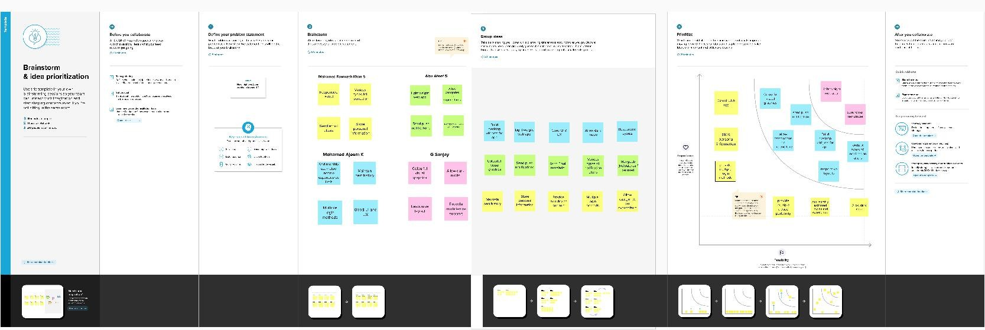

* 1. **Prepare Empathy Map**

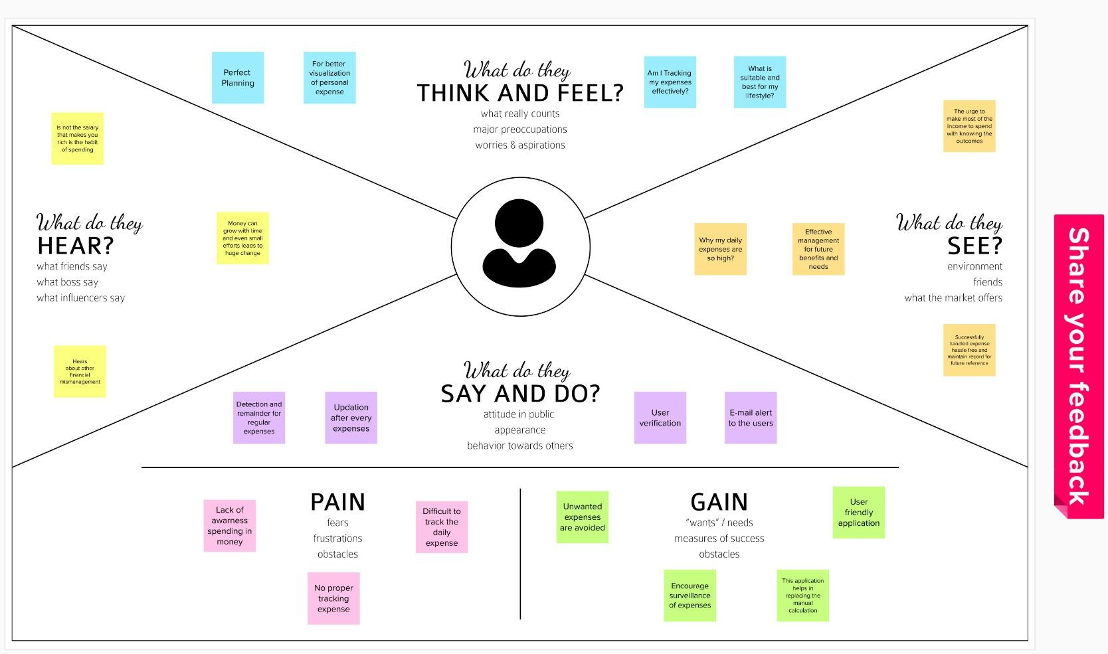

## Proposed Solution

|  |  |  |
| --- | --- | --- |
| S. No | **Parameter** | **Description** |
| 1 | Problem Statement (Problem to be  solved) | The problem to be solved is that people find it hard to keep track of the monthly expenses and also to prevent compulsive  spending. |
| 2 | Idea / Solution description | Personal expense tracker application allows the user to add the income and expenses. Accordingly, the expense  wallet gets  updated. An analysis of the expenditure in graphical form could be obtained. The user also gets notified if the monthly limit for  the budget is exceeded. |
| 3 | Novelty / Uniqueness | The personal expense tracker application helps the user not only in budgeting and accounting; it also provides the  insights  about money management through the analysis. The user  also gets notified if the monthly limit is exceeded. |
| 4 | Social Impact / Customer Satisfaction | The application allows the user to budget, account and get insights on money management. So the users get satisfied  with efficient planning. |
| 5 | Business Model (Revenue Model) | The application can have free and premium version where the user can upgrade to premium version to access additional  features. Also, the premium version may be advertisement  free. |
| 6 | Scalability of the Solution | This application is not only applicable for personal use but also can be extended to business organisations. |

* 1. **Problem Solution Fit**

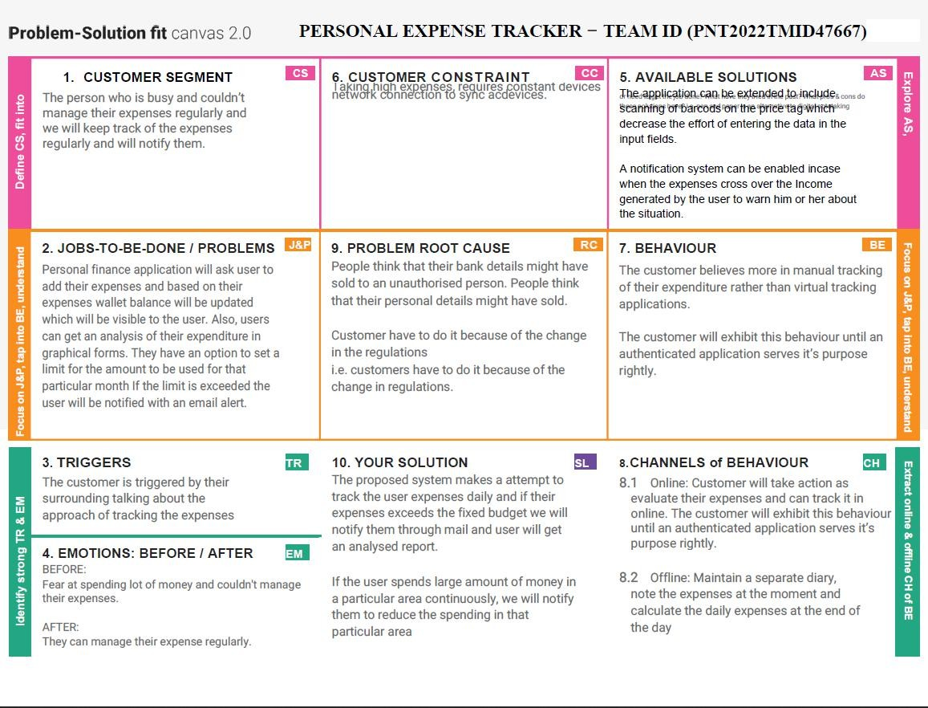

# Requirement Analysis

## Functional Requirements:

Following are the functional requirements of the proposed solution.

|  |  |  |
| --- | --- | --- |
| **FR**  **No.** | **Functional Requirement (Epic)** | **Sub Requirement (Story / Sub-Task)** |
| FR-1 | User Registration | Registration through Form Registration through Gmail  Registration through Linked IN |
| FR-2 | User Confirmation | Confirmation via Email Confirmation via OTP |
| FR-3 | User Access / Login | Login through email id & password |
| FR-4 | User Data | Adding user expenses through input field & categories. |
| FR-5 | User Alert | Alerting through their email id. |

## Non-functional Requirements:

Following are the non-functional requirements of the proposed solution.

|  |  |  |
| --- | --- | --- |
| **FR No.** | **Non-Functional Requirement** | **Description** |
| NFR-1 | **Usability** | Capture and organize your payment receipts to keep track of your expenditure Monitoring the income and tracking all expenditures |
| NFR-2 | **Security** | Increase your team productivity by providing access control to particular users through  custom permissions. |
| NFR-3 | **Reliability** | Increase efficiency and customer  satisfaction with an app aligned to their needs. Seamlessly integrate with existing infrastructure |
| NFR-4 | **Performance** | Deliver an outstanding customer  experience through additional control over the app. |
| NFR-5 | **Availability** | Website, Android App. |
| NFR-6 | **Scalability** | Available anytime at anywhere. It have an ability of computing process to be used in the  range of capabilities. |

# Project Design

## Data Flow Diagrams

A Data Flow Diagram (DFD) is a traditional visual representation of the information flows within a system. A neat and clear DFD can depict the right amount of the system requirement graphically. It shows how data enters and leaves the system, what changes the information, and where data is stored

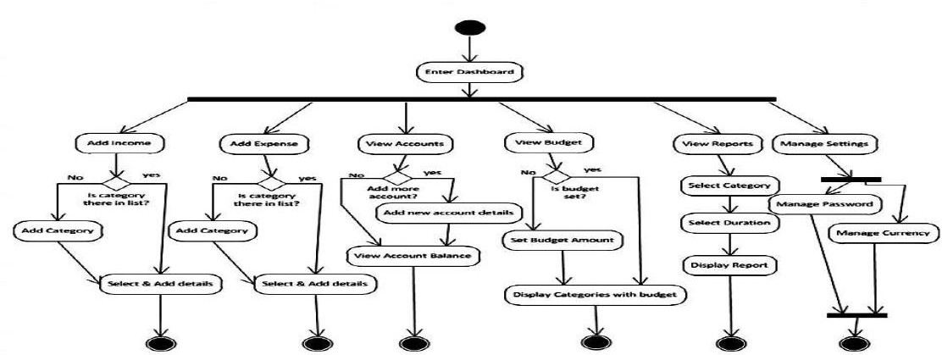

## Solution Architecture

Solution architecture is a complex process – with many sub-processes – that bridges the gap between business problems and technology solutions. Its goals are to: Find the best tech solution to solve existing business problems.

Describe the structure, characteristics, behaviour, and other aspects of the software to project stakeholders.

Define features, development phases, and solution requirements.

Provide specifications according to which the solution is defined, managed, and delivered.

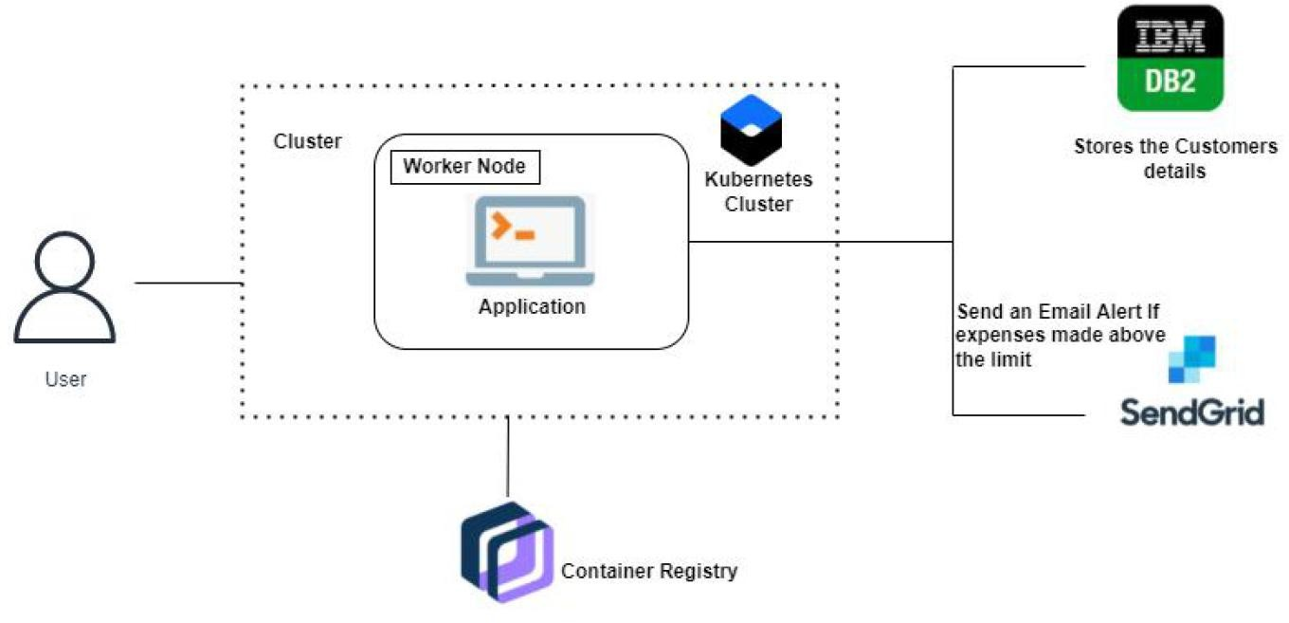

## Technical Architecture

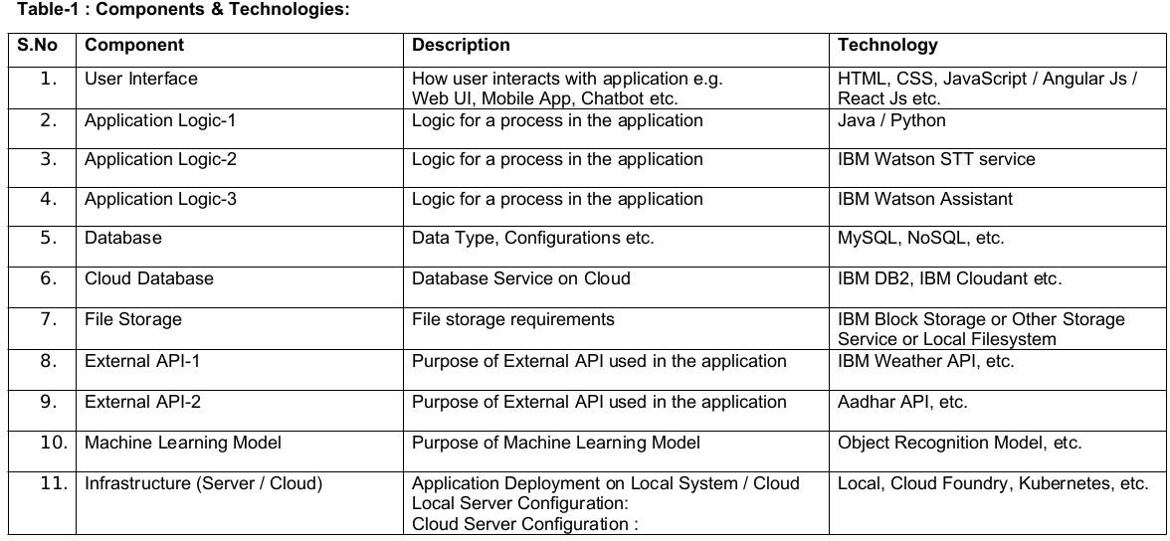The Deliverable shall include the architectural diagram as below and the information as per the table1 & table2

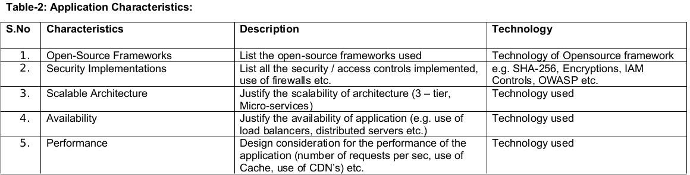

## User Stories

Use the below template to list all the user stories for the product.

|  |  |  |  |  |  |  |
| --- | --- | --- | --- | --- | --- | --- |
| **User Type** | **Functional Requirement**  **(Epic)** | **User Story**  **Number** | **User Story / Task** | **Acceptance criteria** | **Priority** | **Release** |
| Customer (Mobile user) | Registration | USN-1 | As a user, I can register for the application by entering my email, password, and confirming  my password. | I can access my account / dashboard | High | Sprint-1 |
|  |  | USN-2 | As a user, I will receive confirmation email  once I have registered for the application | I can receive confirmation email & click confirm | High | Sprint-1 |
|  |  | USN-3 | As a user, I can register for the application through Facebook | I can register & access the dashboard with Facebook Login | Low | Sprint-2 |
|  |  | USN-4 | As a user, I can register for the application  through Gmail |  | Medium | Sprint-1 |
|  | Login | USN-5 | As a user, I can log into the application by entering email &  password | The mail id and password should be the same. | High | Sprint-1 |
|  | Dashboard | USN-6 | As a user I can enter my income and  expenditure details | I can view my daily expenses. | High |  |
| Customer Care Executive |  | USN-7 | As a customer executive,  I can solve the log  in issue and other issues of the application | I can provide support or solution at any time. | High |  |
| Administrator |  | USN-8 | As an Administrator I can upgrade or update  the application | I can fix the bug which arises for the customers and users of the  application. | Medium |  |

# Project Planning & Scheduling

**6.1Sprint Delivery Schedule**

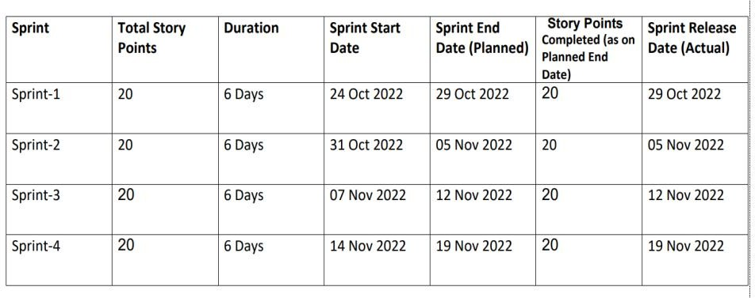

# Coding and Solutioning:

## Features

Feature 1: Add Expense Feature 2: Update Expense Feature 3: Delete Expense Feature 4: Set Limit

Feature 5: Send Alert Emails to users

## Other Features

Track your expenses anywhere, anytime. Seamlessly manage your money and budget without any financial paperwork. Just click and submit your invoices and expenditures. Access, submit, and approve invoices irrespective of time and location. Avoid data loss by scanning your tickets and bills and saving in the app. Approval of bills and expenditures in real-time and get notified instantly. Quick settlement of claims and reduced human errors with an automated and streamlined billing process.

# TESTING

## TESTING:

* + - Login Page (Functional)
    - Login Page (UI)
    - Add Expense Page (Functional)

## User Acceptance Testing:

1. **Purpose of Document**

The purpose of this document is to briefly explain the test coverage and open issues of [product name] project time of the release to User Acceptance Testing (UAT)

## Defect Analysis

This report shows the number of resolved or closed bugs at each severity level, and how they are resolved.

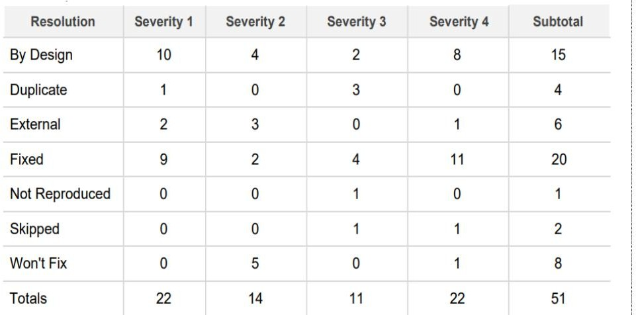

1. **Test Case Analysis**

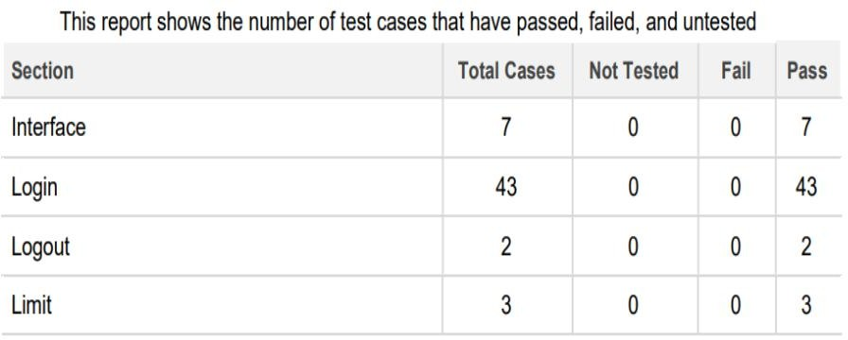

# RESULTS

## Homepage

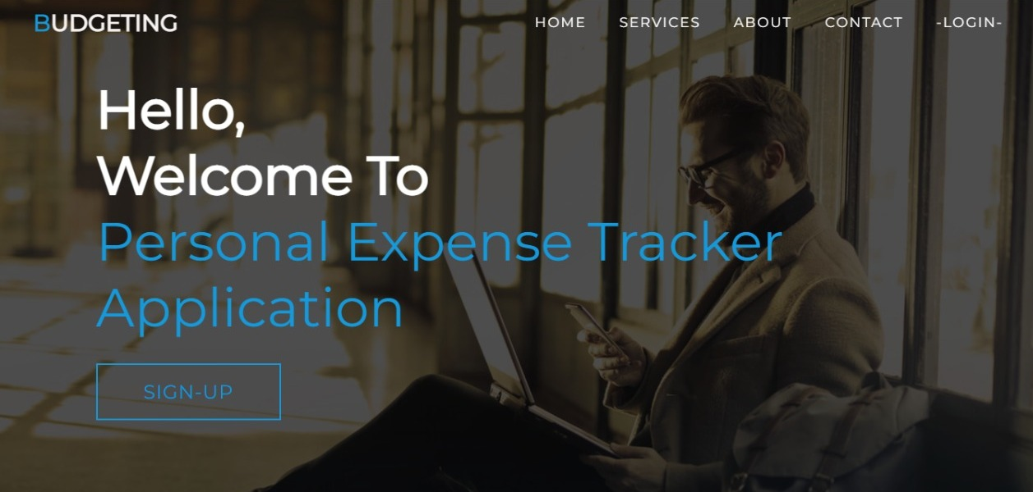

**Signup**

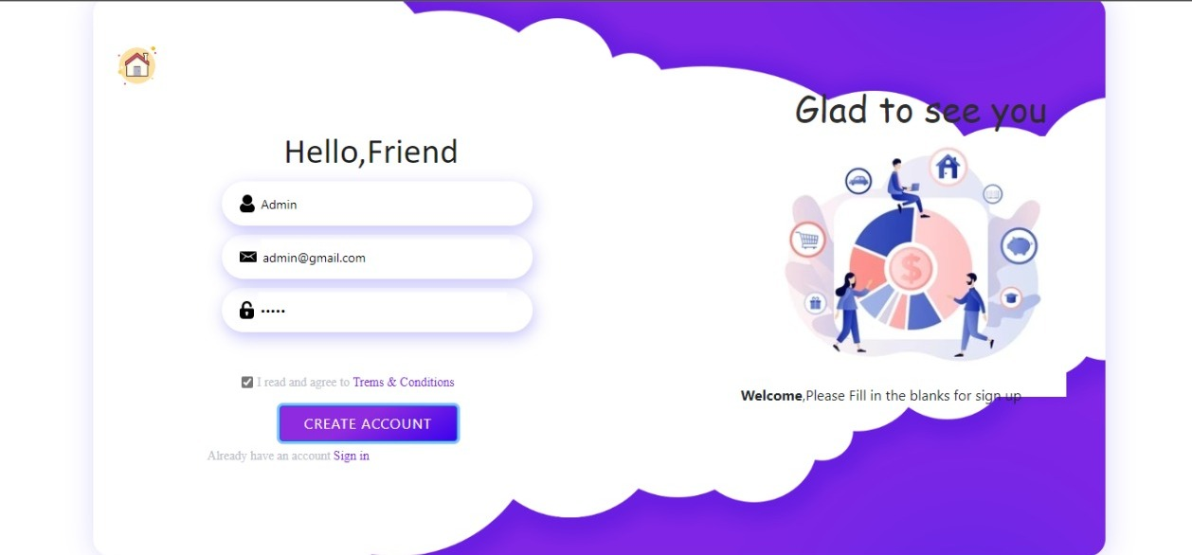

## Login

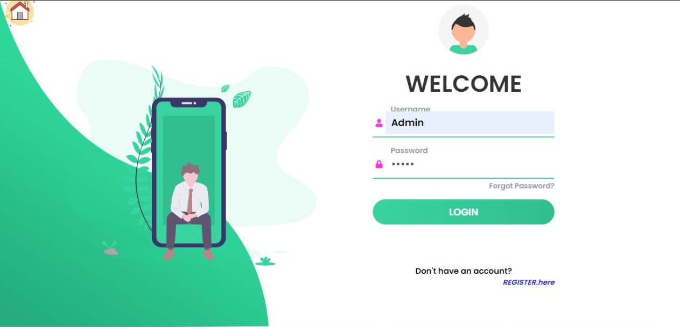

**Adding Expense**

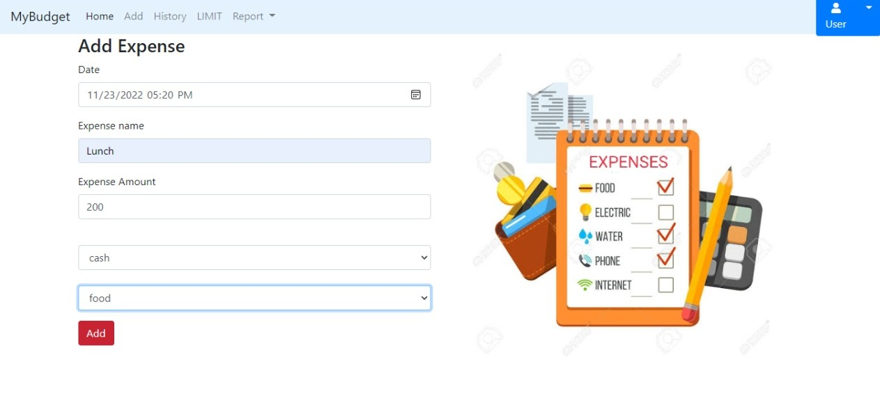

## Expense History

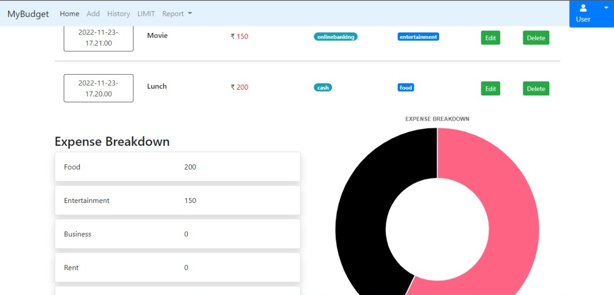

**Expense Limit**

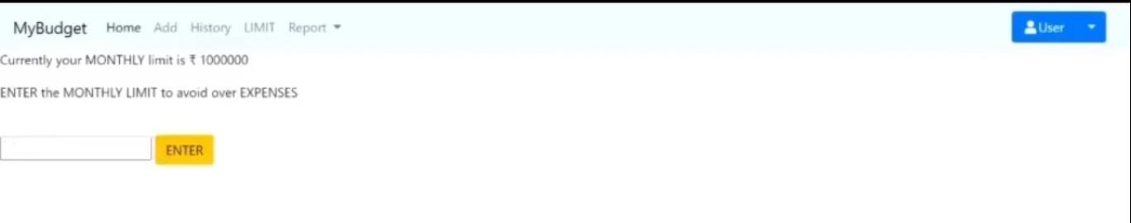

**Dashboard**

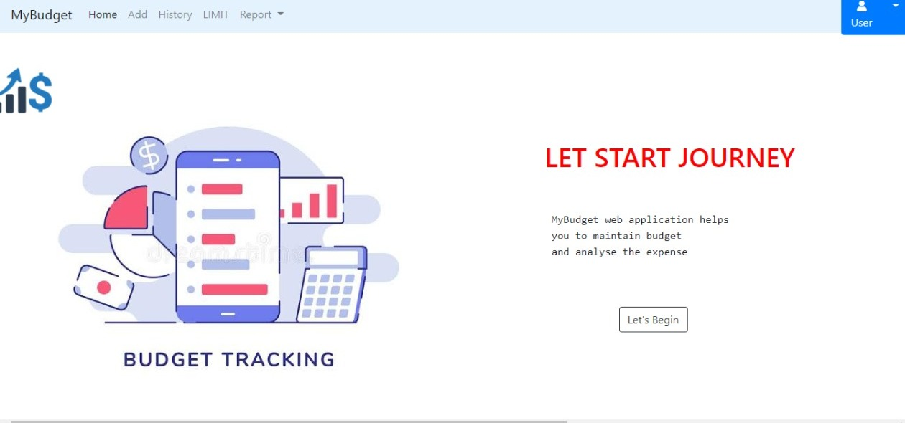

# ADVANTAGES AND DISADVANTAGES

## ADVANTAGES:

One of the major pros of tracking spending is always being aware of the state of one's personal finances. Tracking what you spend can help you stick to your budget, not just in a general way, but in each category such as housing, food, transportation and gifts. While a con is that manuallytracking all cash that is spent can be irritating as well as time consuming, a pro is that doing this automatically can be quick and simple. Another pro is that many automatic spending tracking software programs are available for free. Having the program on a hand-held device can be a main pro since it can be checked before spending occurs in order to be sure of the available budget.

## DISADVANTAGES:

A con with any system used to track spending is that one may start doing it then taper off until it's forgotten about all together. Yet, this is a risk for any new goal such as trying to lose weightor quit smoking. If a person first makes a budget plan, then places money in savings before spending any each new pay period or month, the tracking goal can help. In this way, tracking spending and making sure all receipts are accounted for only needs to be done once or twice a month. Even withconstant tracking of one's spending habits, there is no guarantee that financial goals will be met. Although this can be considered to be a con of tracking spending, it could be changed into a pro if one makes up his or her mind to keep trying to properly manage all finances.

# CONCLUSION

A comprehensive money management strategy requires clarity and conviction for decision- making. You will need a defined goal and a clear vision for grasping the business and personal finances. That’s when an expense tracking app comes into the picture. An expense tracking appis an exclusive suite of services for people who seek to handle their earnings and plan their expenses and savings efficiently. It helps you track all transactions like bills, refunds, payrolls, receipts, taxes, etc., on a daily, weekly, and monthly basis.

# FUTURE SCOPE

* Achieve your business goals with a tailored mobile app that perfectly fits your business.
* Scale-up at the pace your business is growing.
* Deliver an outstanding customer experience through additional control over the app.
* Control the security of your business and customer data.
* Open direct marketing channels with no extra costs with methods such as pushnotifications.
* Boost the productivity of all the processes within the organization.
* Increase efficiency and customer satisfaction with an app aligned to their needs.
* Seamlessly integrate with existing infrastructure.
* Ability to provide valuable insights.
* Optimize sales processes to generate more revenue through enhanced data collection.

Chats: Equip your expense tracking app with a bot that can understand and answer alluser queries and address their needs such as account balance, credit score, etc.

* Prediction: With the help of AI, your mobile app can predict your next purchase, according to your spending behavior. Moreover, it can recommend products and provideunique insights on saving money. It brings out the factors causing fluctuations in your expenses.

# APPENDIX:

**SOURCE CODE**

**Link: https://github.com/IBM-EPBL/IBM-Project-4511-1658733713/tree/main/Final%20Deliverables/Final%20code**

**GITHUB AND PROJECT DEMO LINK**

**GitHub link: https://github.com/IBM-EPBL/IBM-Project-4511-1658733713**

**Video Demo Link: https://drive.google.com/file/d/1s5-8bo2E7d38oCFoU95pMw-LAqoV0lTf/view?usp=drivesdk**